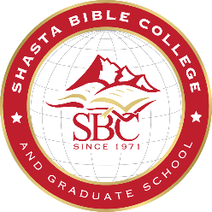
PETITION TO GRADUATE-AUGUST 2018
This petition represents a request to have your records reviewed to verify that all graduation requirements have been completed. It is your responsibility to assure that all graduation requirements are met. The date on your degree is determined by the semester in which you complete your academic requirements.

My name should read on my diploma as follows:
First: | Middle: | Last:

I am petitioning for the following degree: (check one)
Certificate in Biblical Studies M.A. in Biblical Counseling
Certificate in Early Childhood Education M.A. in Christian Ministry
A.A. in Biblical Studies M.A. in Christian Family Life Education
A.A. in Early Childhood Education M.Div.
B.A. in Bible and Theology M.S. in Education
B.A. in Education
B.A. in Christian Professional Studies

Emphasis (if applicable):

You may choose to walk in either the May 12, 2018 Commencement or the May 11, 2019 Commencement. Please choose which one and provide the following info:
2018: 2019: Height: Weight:

If you are a Master’s student, who is not participating in the annual ceremony, would you like a “hood” sent to you along with your diploma? Yes No

Send my degree to: Check here if the following is a new address.
Address:
Please provide your current contact information:
Phone: | E-mail:
I plan to pay the $125 graduation fee by Cash Check Visa MasterCard
Card #: |  | Expiration Date:

Please sign and date (Electronic signature accepted)
Signature: | Date:

Please write a short testimony of your future plans. This information may be used in our newsletter, graduation program, and/or web site. Use the back of this form if necessary:

