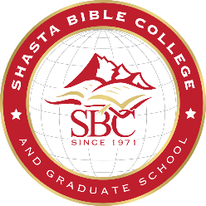
PETITION TO GRADUATE-DECEMBER 2021
This petition represents a request to have your records reviewed to verify that all graduation requirements have been completed. It is your responsibility to assure that all graduation requirements are met. The date on your degree is determined by the semester in which you complete your academic requirements.

My name should read on my diploma as follows:
First: | Middle: | Last:

I am petitioning for the following degree: (check one)
Certificate in Biblical Studies M.A. in Biblical Counseling
Certificate in Early Childhood Education M.A. in Christian Ministry
A.A. in Biblical Studies M.S. in Education
A.A. in Early Childhood Education M.Div.
B.A. in Bible and Theology
B.A. in Education
B.A. in Christian Professional Studies

Emphasis (if applicable):

While degrees are granted at the end of each semester, there is only one commencement service in May which you are invited to participate in. Graduating in December 2021 makes you eligible for the May 14, 2022 Commencement.

There is a $200 Graduation Fee that will be billed to your account in Populi during the semester of your graduation date. This is required regardless of whether or not you participate in the ceremony in May.

Please note that you must have your full financial obligations, including any fees, paid in full one week prior to your graduation date in order to be eligible for graduation. If you owe a financial balance after that date, you will not be able to graduate until it has been resolved. No exceptions.

I am planning on participating in the May 14, 2022 graduation ceremony: Yes No

If you plan on walking at our Commencement on May 14, 2022 please provide the following info for your graduation attire:
Height: Weight:

If you are a Master’s student, who is not participating in the annual ceremony, would you like a “hood” sent to you along with your diploma? Yes No

If you are not attending, please let us know where to send your diploma: Check here if the following is a new address.
Address:

Please sign and date (Electronic signature accepted)
Signature: | Date:

Please write a short testimony of your future plans. This information, along with your picture, may be used in our newsletter, graduation program, and/or website.

