**The Country Bible Church**

**23552 SR 127, LaCrosse, WA 99143 Email: cbcdusty@gmail.com**

The Country Bible Church is a non-denominational Bible believing church that is proud of our hometown values and agriculture roots. Country Bible Church is located in the Pacific Northwest nestled in the heart of Whitman County in what is known as the famous Palouse Region, the beautiful and bountiful farming area of Eastern Washington.

CBC was established in 1908 and our current membership is about 20-25. We are located halfway, 80 miles, between the cities of Spokane and Walla Walla WA on Highway 127, just outside of the small town of Dusty that carries that original comfortable Western feeling!

We are a friendly, committed body of believers who truly care about each other and our community.

We feel our mission is to Glorify God and to worship the Lord with passion and serve Him with excellence by training and equipping believers in the Word of God, by ministering to the needs of the saints and showing the love of Christ by equipping the saints to do the work of the ministry as we go forth winning souls for Christ!

There is a Parsonage available, that is two miles from the church. Cozy and quiet, it is a bungalow style house, with a comfortable front porch with a beautiful interior. On the main floor are three bedrooms, including a parlor, a dining room, a spacious farm style kitchen, bathroom, an office and a utility room. A second bathroom is located in the basement and the upstairs dormitory provides extra space.

The pastor and his family are encouraged to live there, but it is not mandatory.

**Our wonderful schools!**

Colfax Schools:

Colfax Senior High School 509-397-4368

Jennings Elementary 509-397-2191

<https://www.csd300.org/>

LaCrosse School District 509-549-3591

<https://www.lacrossesd.k12.wa.us/en-US#0>

**Dusty is close to many major Colleges and Universities**

Gonzaga University

<https://www.gonzaga.edu/>

Washington State University

<https://wsu.edu/>

University of Idaho

<https://www.uidaho.edu/>

Whitworth University

<https://www.whitworth.edu/cms/>

Eastern Washington University

<https://www.ewu.edu/>

Lewis Clark State College

<https://www.lcsc.edu/>

**Medical Facilities**

Whitman County is very blessed to have a modern advanced hospital and medical services available.

<https://www.whmc.org/>

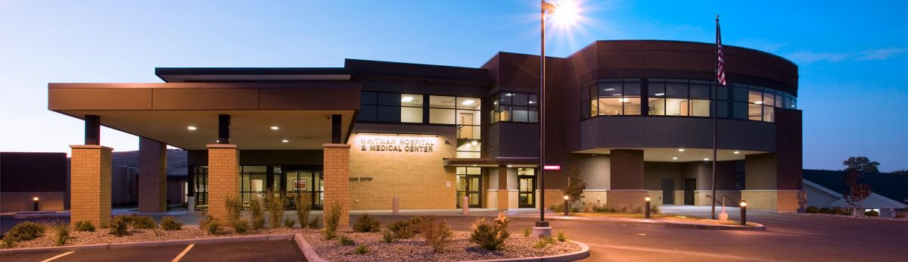

**Local Activities and Things of Interest**

**The Palouse Region**offers a wide range of events, from seasonal festivals and sports competitions to spending time in our local parks where you can relax with your family for an afternoon of outdoor fun. There are lots of activities to choose from.

**The Palouse Empire Fair and Rodeo**

<https://www.palouseempirefair.com/>

**Boyer Park and Marina**

<https://koa.com/campgrounds/boyer-park/>

**The Palouse Scenic Byway**

<https://www.palousescenicbyway.org/explore-1>

**The Palouse Falls**

<https://www.wta.org/go-hiking/hikes/palouse-falls>

**Hells Canyon**

<https://visitlcvalley.com/hells-canyon/>

**Get to know the surrounding area**

<https://www.colfaxwa.org/home>

<http://www.lacrossewa.us/>

<https://www.pullman-wa.gov/>

<https://www.wallawallawa.gov/>

<https://www.visitspokane.com/>

https://www.cityoflewiston.org/